**RESUME**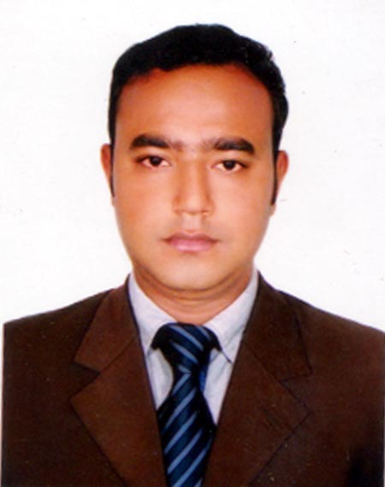

**0F**

**MD.SHAMIM MIAH**

8nd Floor (East Side),Road No:06,

Merul Badda, DIT Project,

Dhaka-1212

Mobile: 01712-700069

E-Mail : [sisirmhmd@gmail.com](mailto:sisirmhmd@gmail.com)

**Career Objectives:**

To work as a team member and develop my career in any renowned organization where I can utilize my knowledge and skill for the utmost satisfaction.

**Experience:**

**01.Probashi Polli Group – (**1st January 2019 to Continue)

**Position:** Senior Executive (Sales & Marketing )

**Key Responsibilities:**

1.Organising sales visits.

2.Demonstrating and presenting products.

3.Establishing new business.

4.Maintaining accurate records.

5.Attending trade exhibitions, conferences and meetings.

6.Negotiating contracts and packages.

7.Aiming to achieve monthly or annual targets.

**02.ACI LIMITED (PANASONIC) – (**1st January 2016 to 30 November 2018)

**Position:** Senior Officer (Sales)

**Key Responsibilities:**

1. Achieving monthly sales target.

2. Receiving customer complaints & providing customer services,

3. Build-up new customer and increasing sales volume.

4. Participate in meetings, discussions.

5. Prepare the organizational all kinds of sales related papers.

6. Monitoring and research for the development of product.

**Educational Qualification:**

**Name of Examination : Masters of Business Administration (MBA)**

Major: Finance

Result : CGPA-3.48

Year of Passing : 2014

Name of Institution : Bangladesh Islami University, Dhaka

**Name of Examination : Bachelor of Business Administration (BBA)**

Major: Finance

Result : CGPA-3.68

Year of Passing : 2013

Name of Institution : Bangladesh Islami University, Dhaka

**Name of Examination : Higher Secondary Certificate (H.S.C)**

Result : GPA- 4.30

College : Govt. Yasin College

Board : Dhaka

Year : 2008

Group : Business Studies

**Name of Examination : Secondary School Certificate (S.S.C)**

Result : GPA- 4.81

School : Brahmon Kanda A.S.Academy

Board : Dhaka

Year : 2006

Group : Business Studies

**Computer Skills:**

MS Word, MS Excel, MS Power Point as well as Internet Browsing.

**Language Proficiency:**

**English** : Excellent Speaking, Listening & Writing.

**Bangla** : Good in Listening, Writing, Spoken-Average.

**Hobby & Sports:**

I am a Singer, Sing Song, Write Song, Traveling, Watching Movie,

Cricket & Football.

**Personal Information:**

Father's Name : Rustom Ali Miah

Mother's Name : Aleya Begum

Permanent Address : Vill- Nazirpur, Post- Pukhuria, P.S-Bhanga,

Dist-Faridpur

Religion : Islam

Date of Birth : 15th July, 1989

Nationality : Bangladeshi (By birth)

Height : 6’

**References:**

|  |  |
| --- | --- |
| **Md.Kamal Hossan**  Manager  Department of Finance  **Wilts Marketing Company Ltd.**  Cell: 01713-544453 | **Md. Parvez Ahmed**  Business Development Officer  **Standard Chartered Bank**  Cell: 01713-530986 |

**Signature:**

**( Shamim Miah)**